Game Design Document

Fill up the Following document

1. Write the title of your project.

Ballet bash

1. What is the goal of the game?

To help the users learn certain steps of ballet

1. Write a brief story of your game?

The idea is to give the users an insight on how to do ballet steps and they would be encouraged to play a maze runner game at the end to test their knowledge.

1. Which are the playing characters of this game?

* Playing characters are the ones which respond to the user based on the input from the user
* Cars, monkeys, dinos, wizards etc, are the playing characters in the game.

|  |  |  |
| --- | --- | --- |
| Number | Character Name | What can this character do? |
| 1 | Ballet dancer | Play the maze runner game and do steps that have been learnt. |
| 2 |  |  |
| 3 |  |  |
| 4 |  |  |
| 5 |  |  |
| 6 |  |  |
| 7 |  |  |
| 8 |  |  |

1. Which are the Non Playing Characters of this game?

* Non Playing characters are the ones which don't have an action or a behaviour when the user interacts with the game.
* Hurdles, stones, bananas, coins, etc are non playing characters in the game.

|  |  |  |
| --- | --- | --- |
| Number | Character Name | What can this character do? |
| 1 | - |  |
| 2 | - |  |
| 3 | - |  |
| 4 | - |  |
| 5 | - |  |
| 6 | - |  |
| 7 | - |  |
| 8 | - |  |

Draw your imagination of this game. What does this game look like?

* Draw the game either on your computer or on paper,
* Add images of scenes of the game to show each of the playing and non-playing characters at least once.

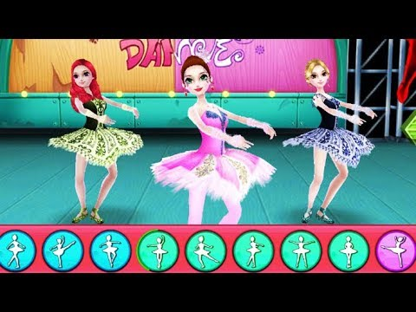

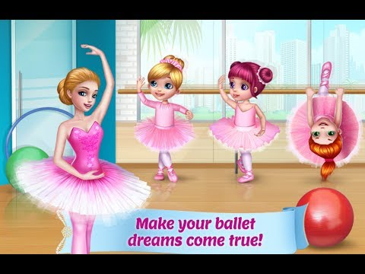

How do you plan to make your game engaging?

I plan to make my game engaging with a different array of ballet moves along with an engaging maze runner game. I also plan to implement visually appealing animations.